**CICD EXPERIMENT – 2**

**Jenkins integration with GitHub**

1. Start the Jenkins service using “java –jar Jenkins.war” in command prompt
2. Go to “localhost:8080” in a web browser
3. Click “New Item” option in Jenkins dashboard. Enter the item name and select freestyle project

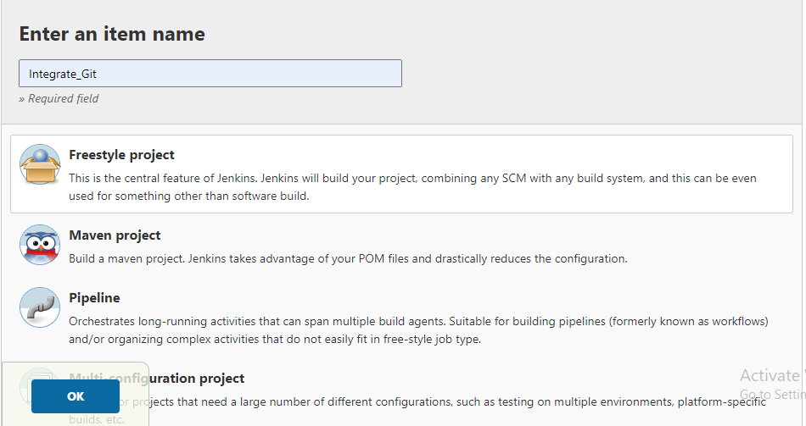

1. Now go to source code management tab and enter the URL of the github repository you want to integrate with and hit save button

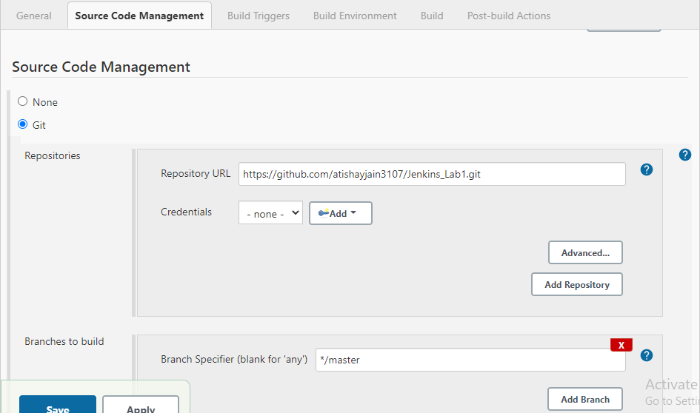

1. Select build now option available and go to console output to check the output.

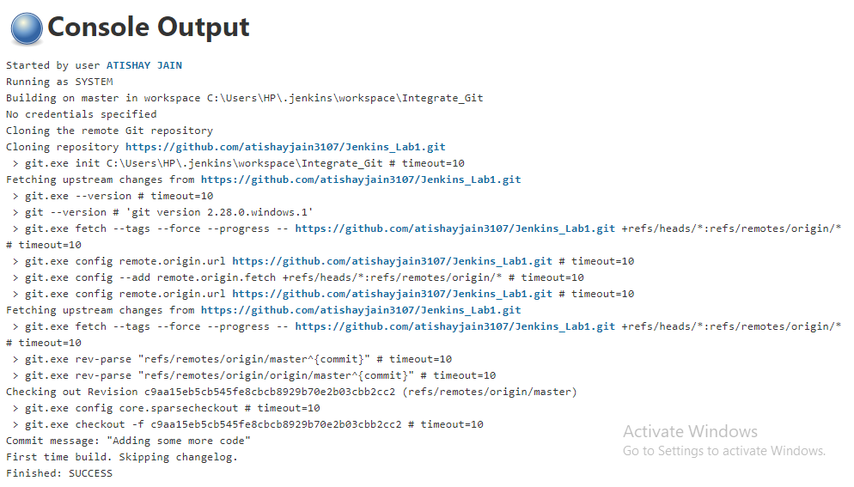

ATISHAY JAIN

500067694

R171218030

CSE, DEVOPS